**Web Technology**

**XML Lab 2 Manual**

1. A sample XML Document of a catalog is given. Prepare an External DTD of the XML Document. Ensure following :-
   1. There is at least one child of the root element.
   2. Element "article" has an "abstract" and Element "book" has a "description".
   3. There can be more that one authors
2. Write a PHP program and create "Summary.php" which displays the details of Books and Articles in the XML file in separate tables with appropriate heading of "Book Summary" / "Article Summary".

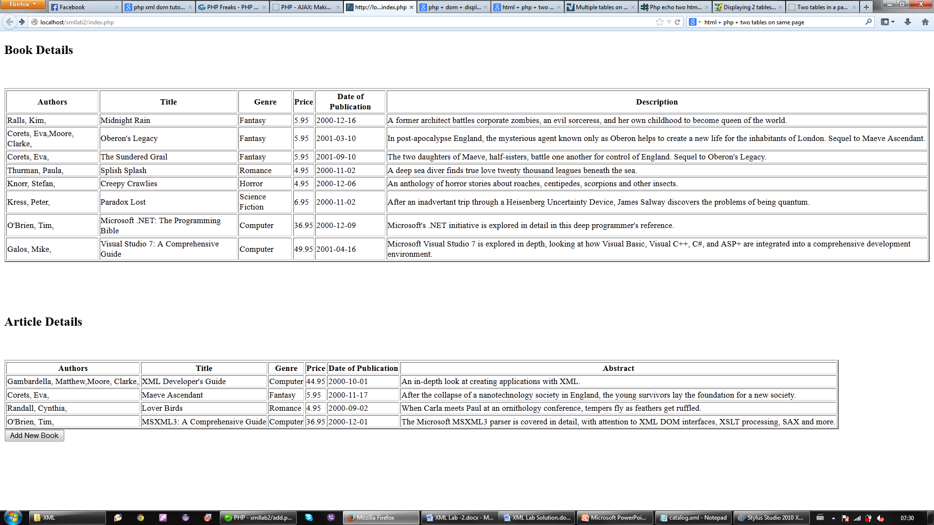

1. Update the summary page by adding a new button "Add Book" that can be used to add a new book.
   1. Navigate to a "addbook.php" when "Add Book" is clicked.
   2. Display an input form for adding data relevant to new book.
   3. Upon click of "Add Book" button in "addbook.php", navigate back to summary.php
   4. the Book Table should now display the data of new book as well in the table.

